SECURE PASS

A SECURED PASSWORD MANGER

7/18/2021

CSE IV C

SHARAN KUMAR

SRUJAN KASHYAP D

SHREYAS KV

SHREYA MP

INDEX

# PROBLEM STATEMENT

Passwords are difficult to remember, and users have many accounts that require passwords. This causes users to choose a memorable but weak password and then reuse them in all the websites, applications and all over the internet, which creates major security problems.

We propose a method for users to only need to remember one password that they can use to access all their passwords at a single application without any complications.

# APROACH

* User registers in the application
* After that users can sign in to their newly created account.
* They just have to remember the master password.
* After successful login, users can add all their username and passwords along with the respective website or application name, also users can include some secure notes if they want to.
* Everything will be stored in the database.

# BENEFITS

1. Never forget passwords or have to write them down.
2. As little memorisation as possible.
3. Access from anywhere.
4. User tested.

The Complete Project Tree and The Dependencies Used:

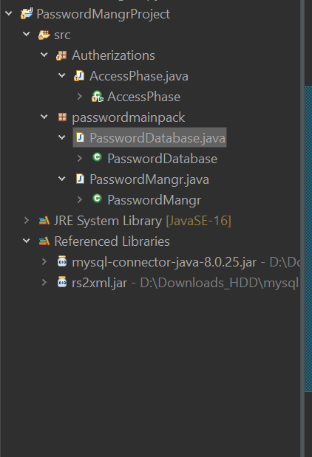

Special Note: If you find black patches on some images – it indicates password of the database. Since we are concerned about Securing Password, we can’t reveal it.

Code for Main Functional Frame:

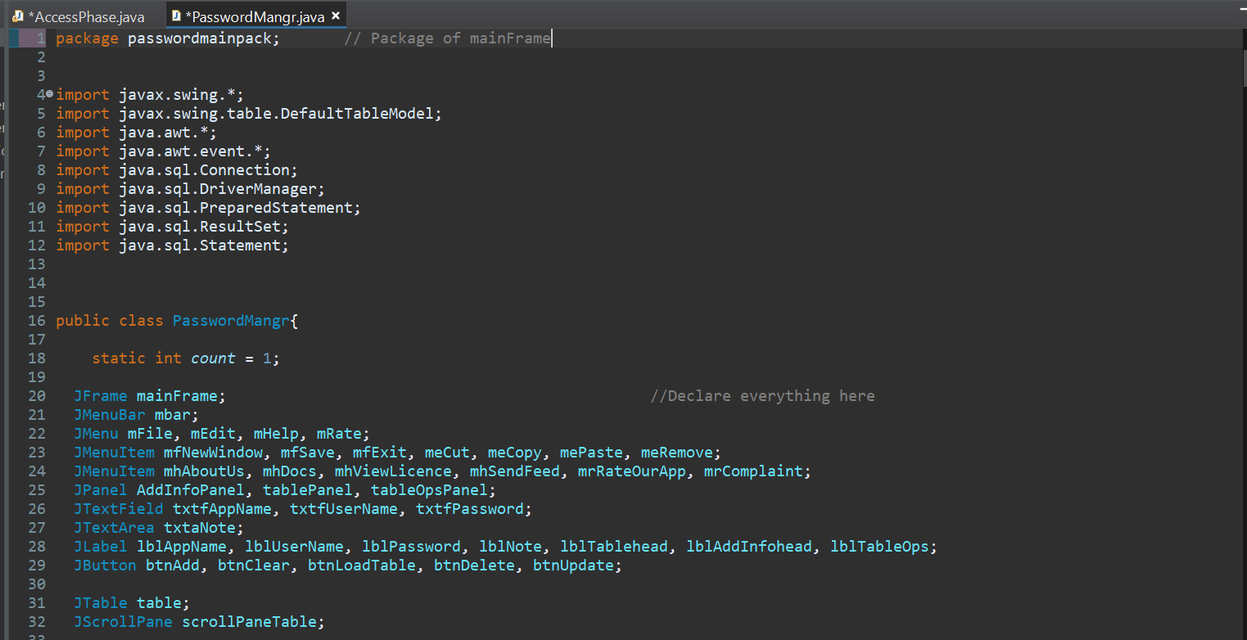

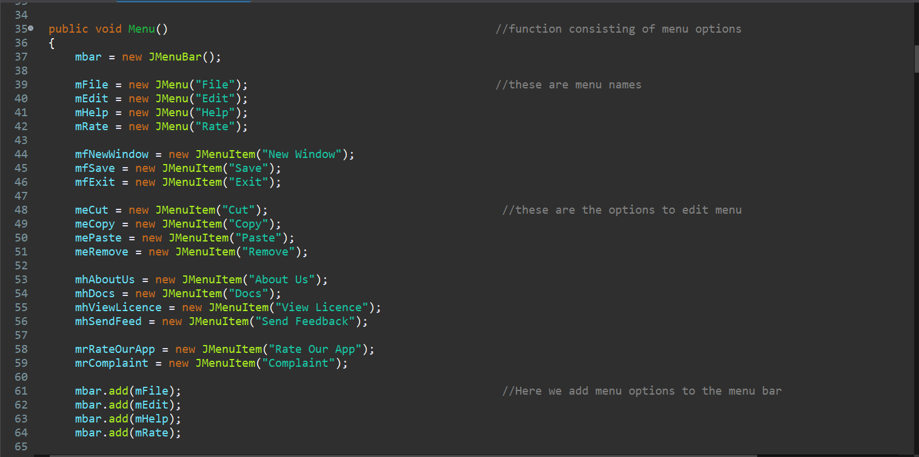

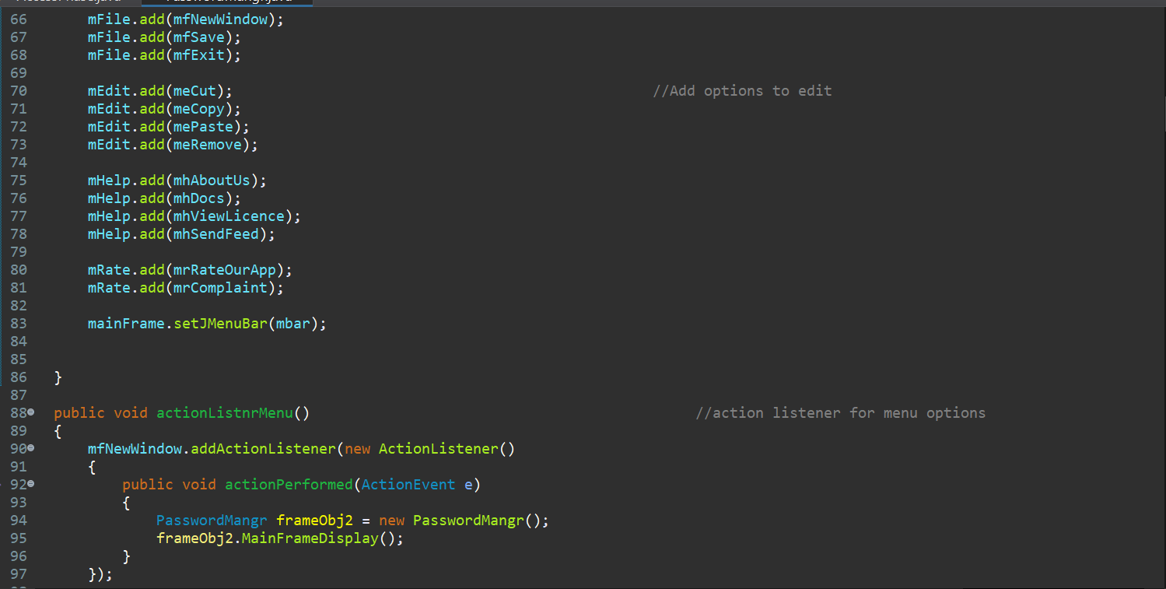

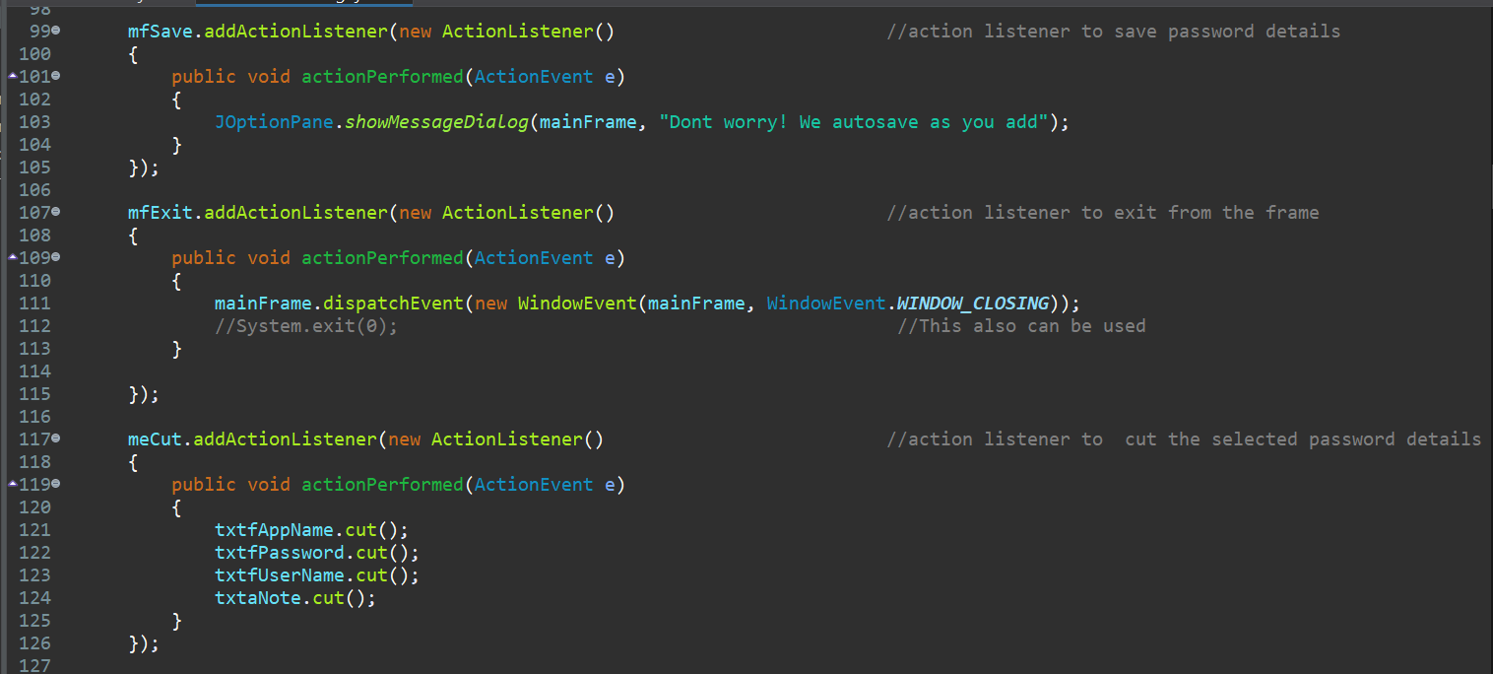

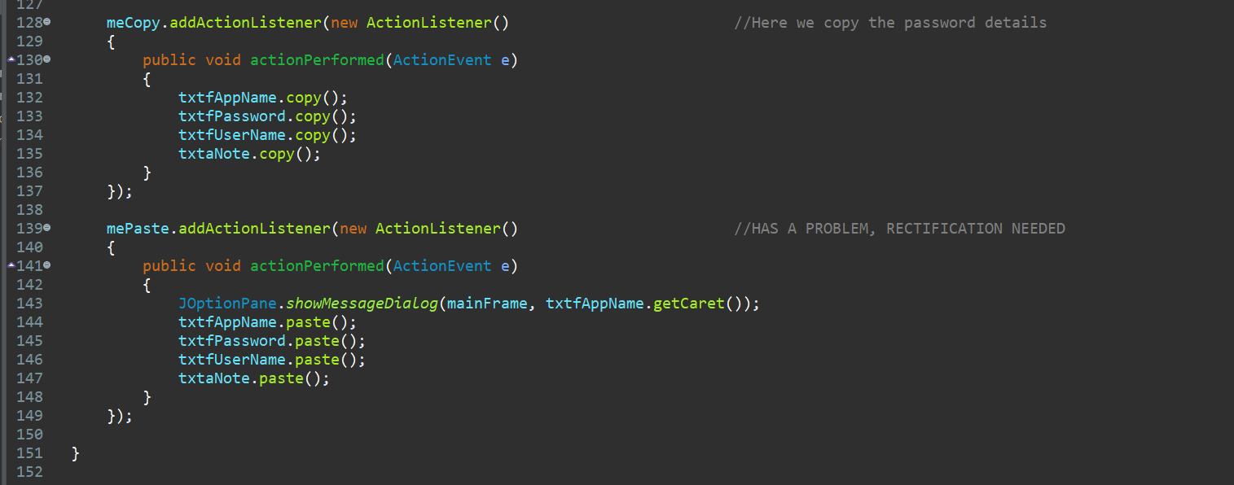

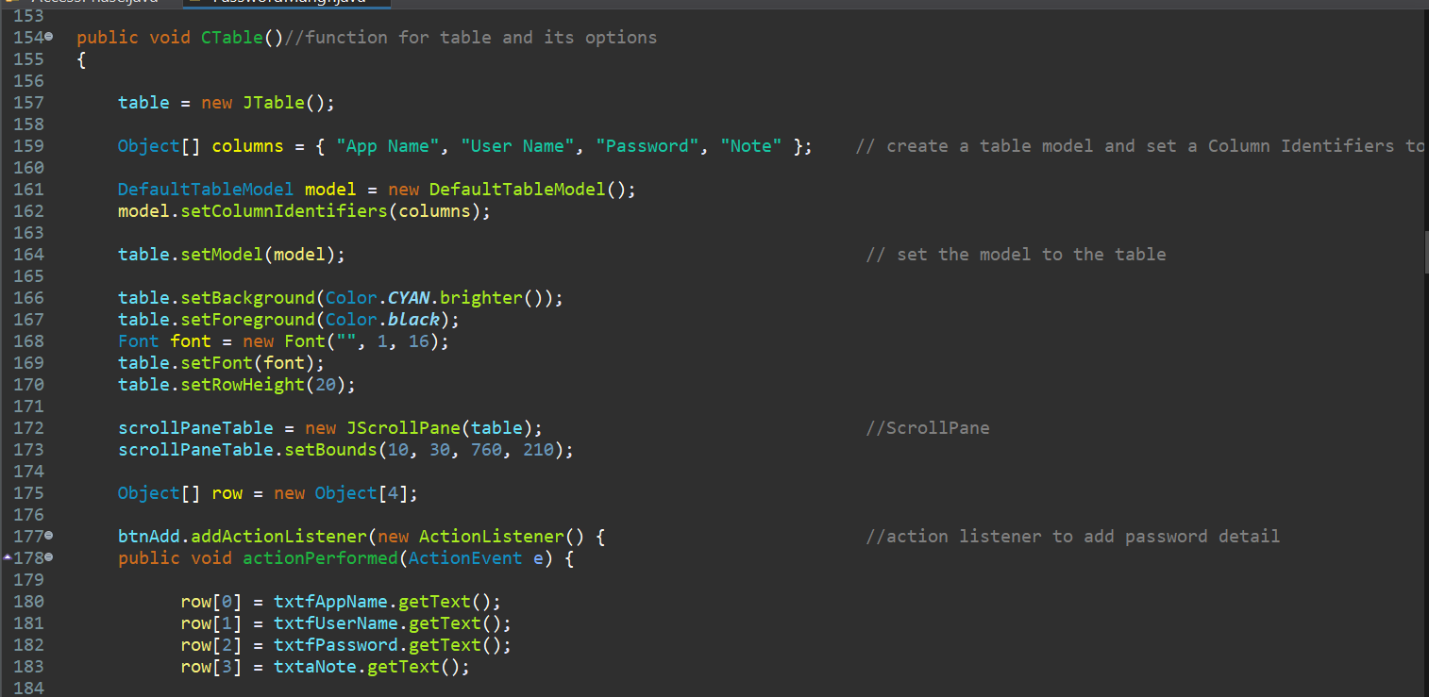

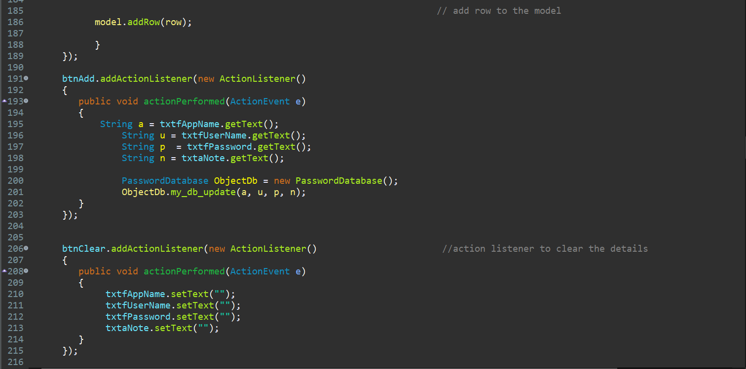

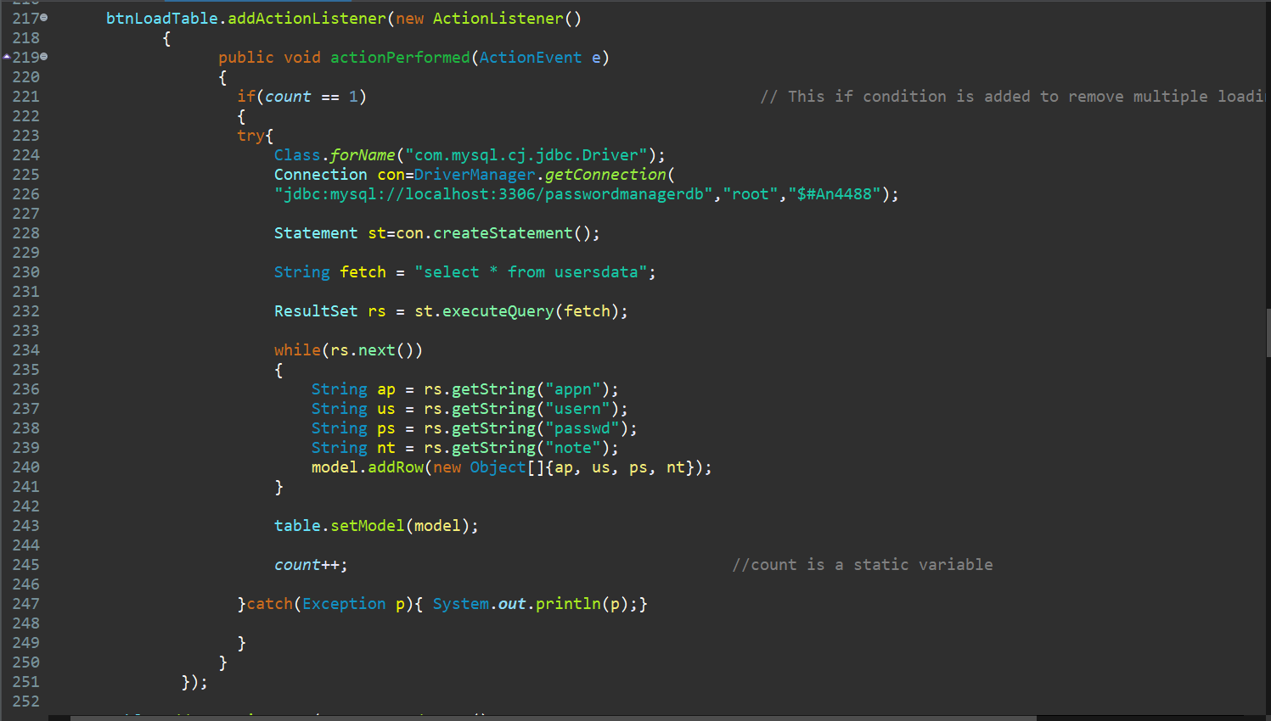



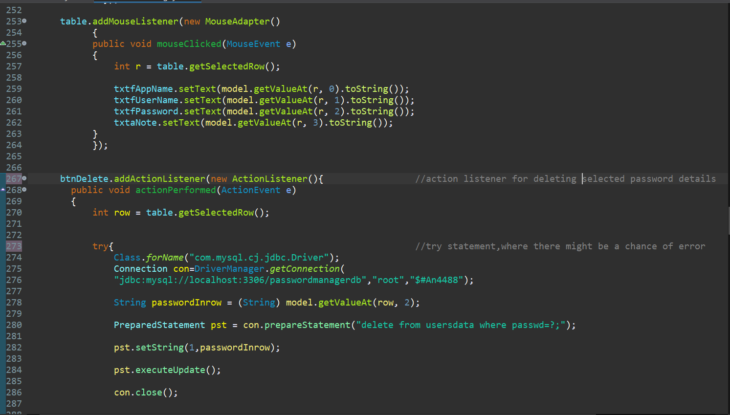



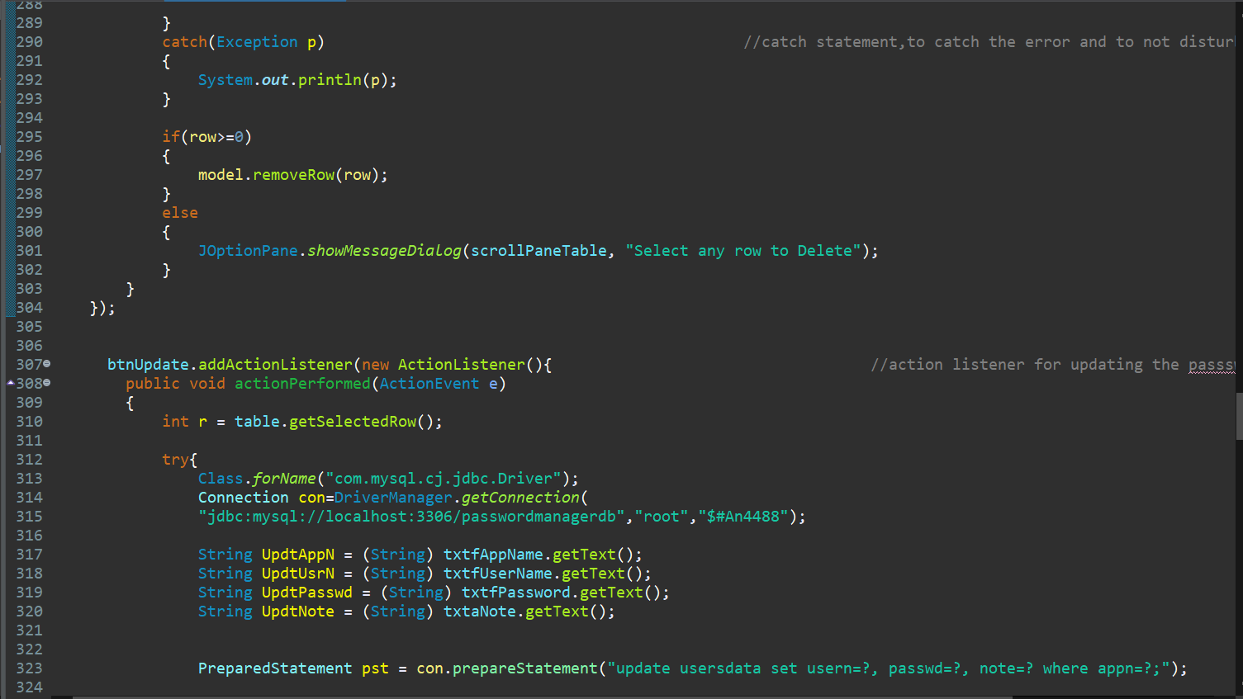



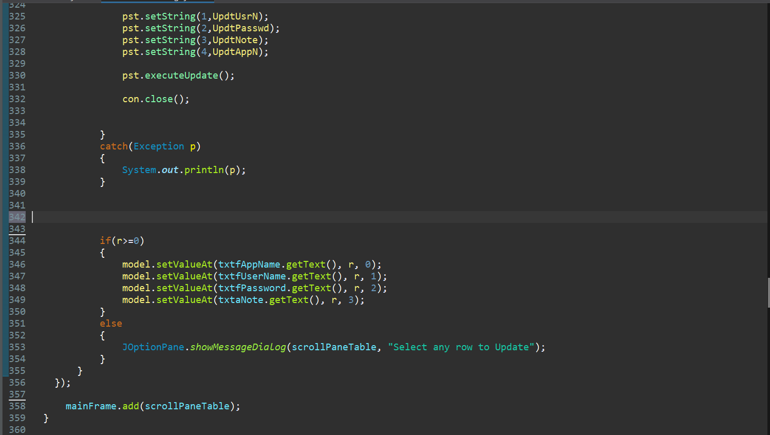

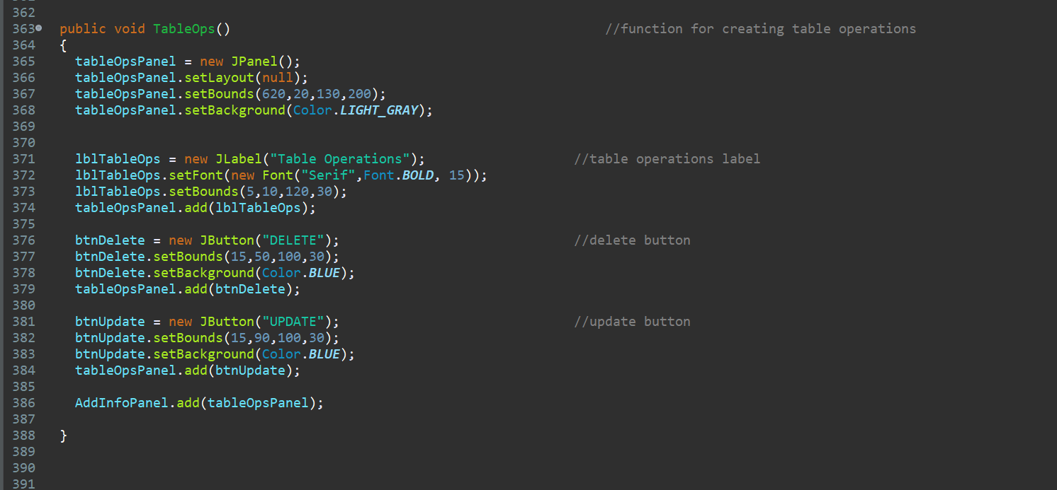

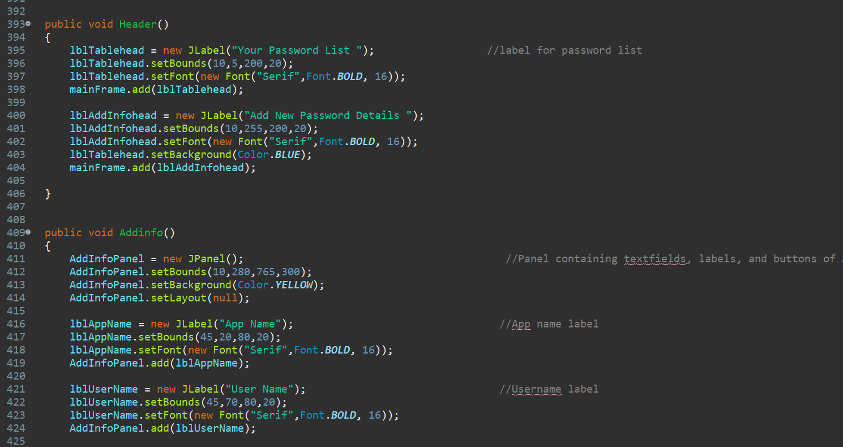

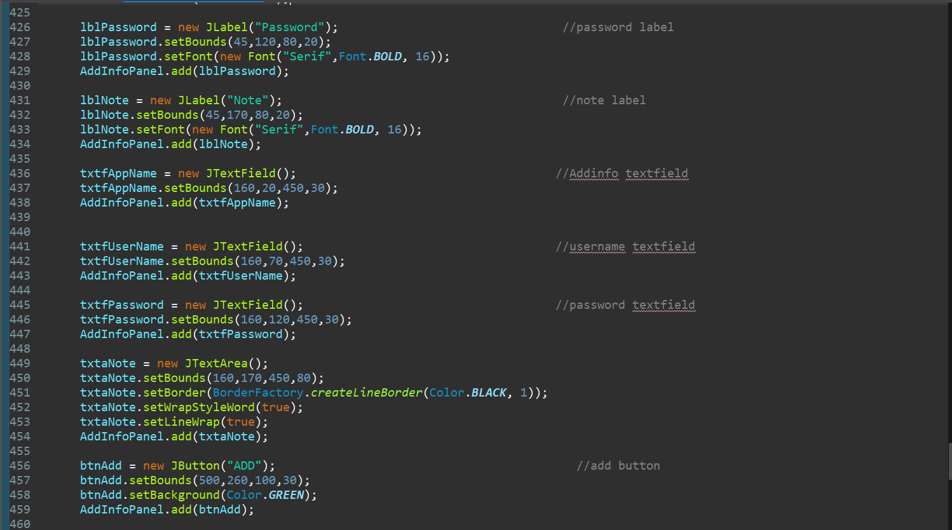

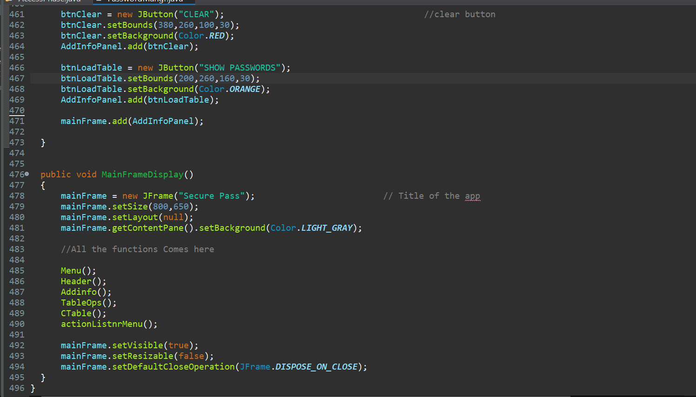

Authorization Section ( Contains main function ) :

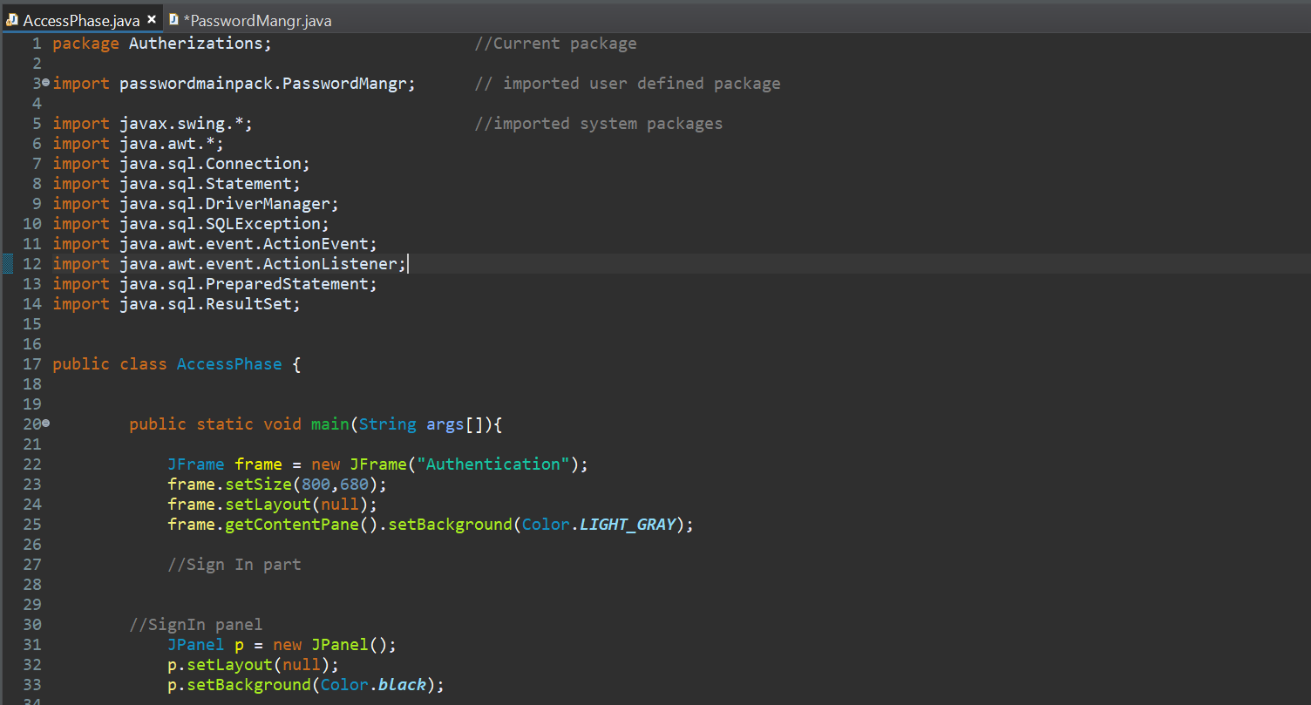

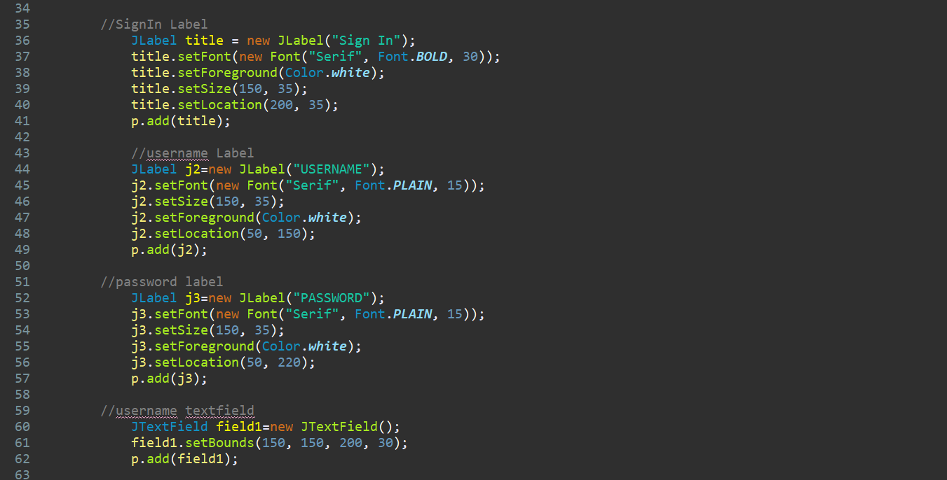

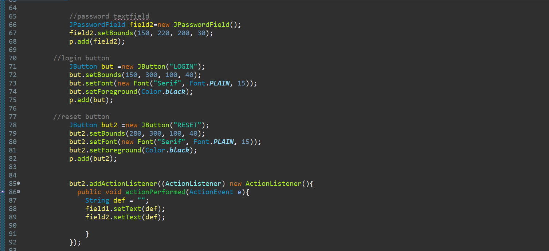

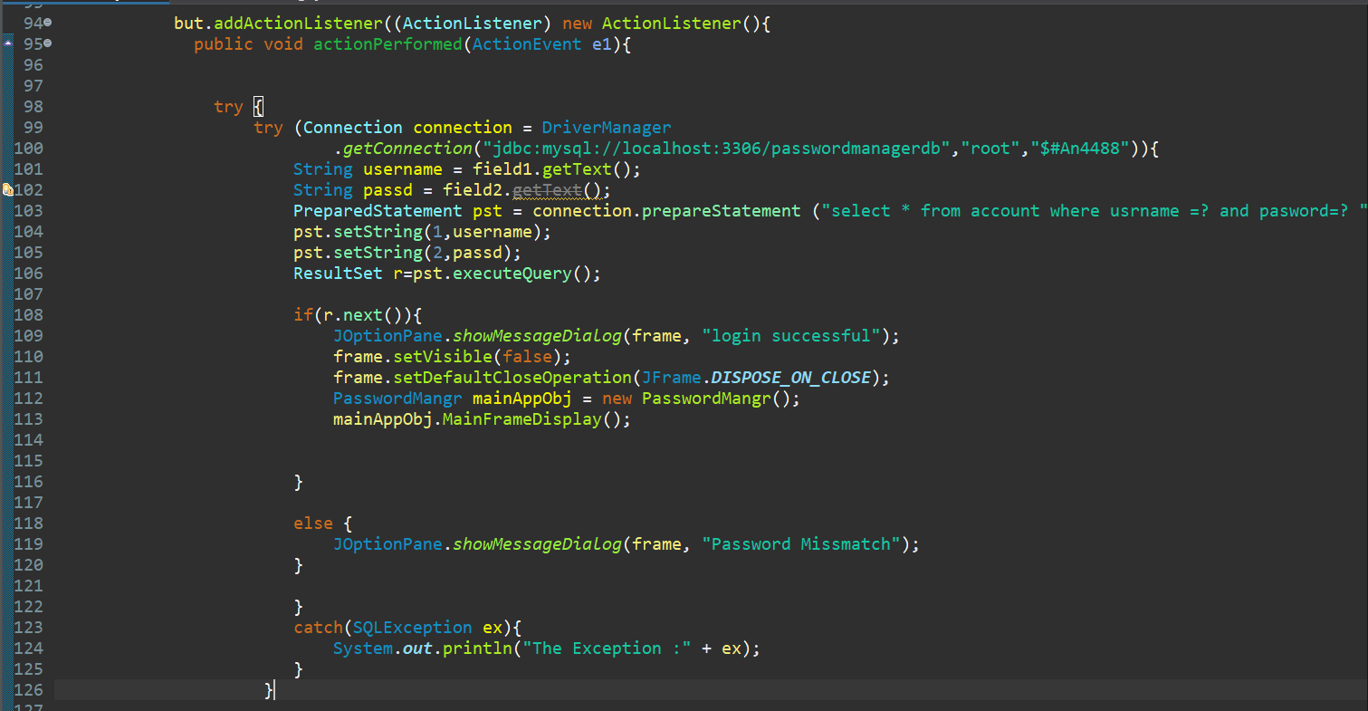



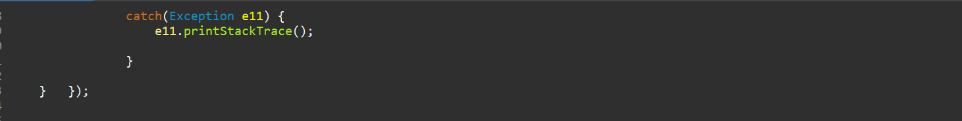

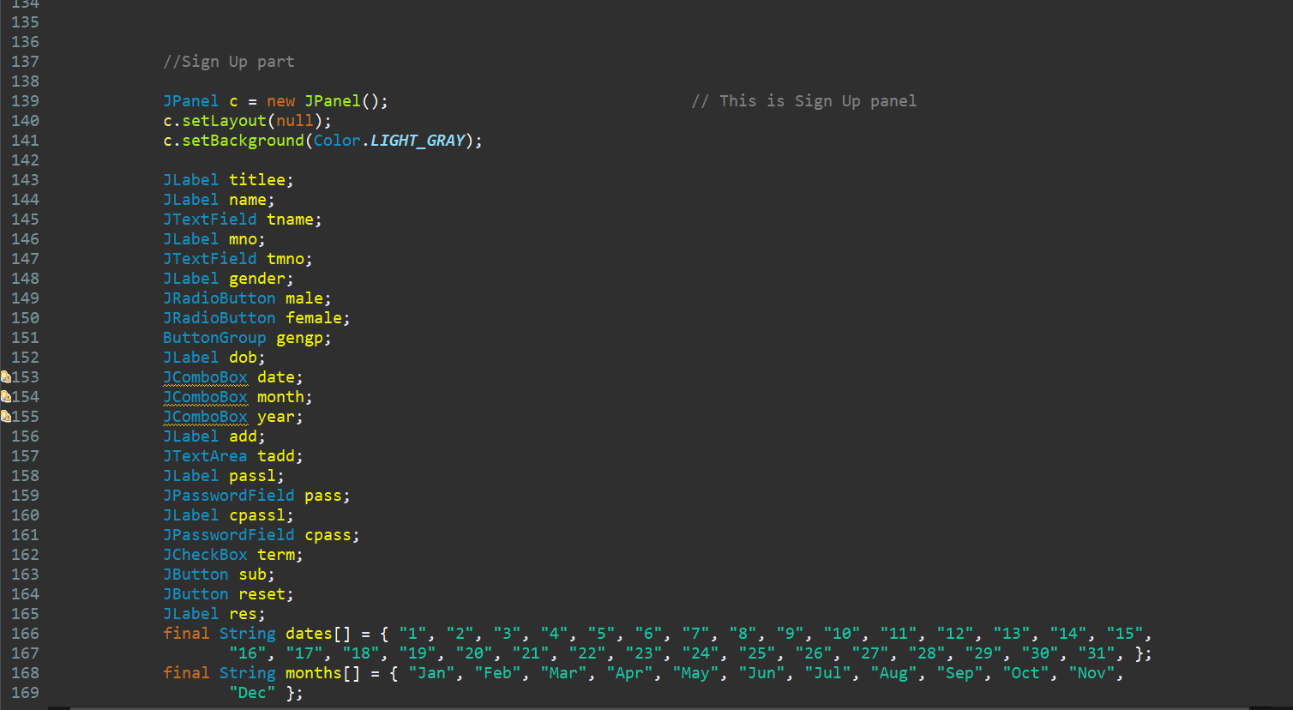

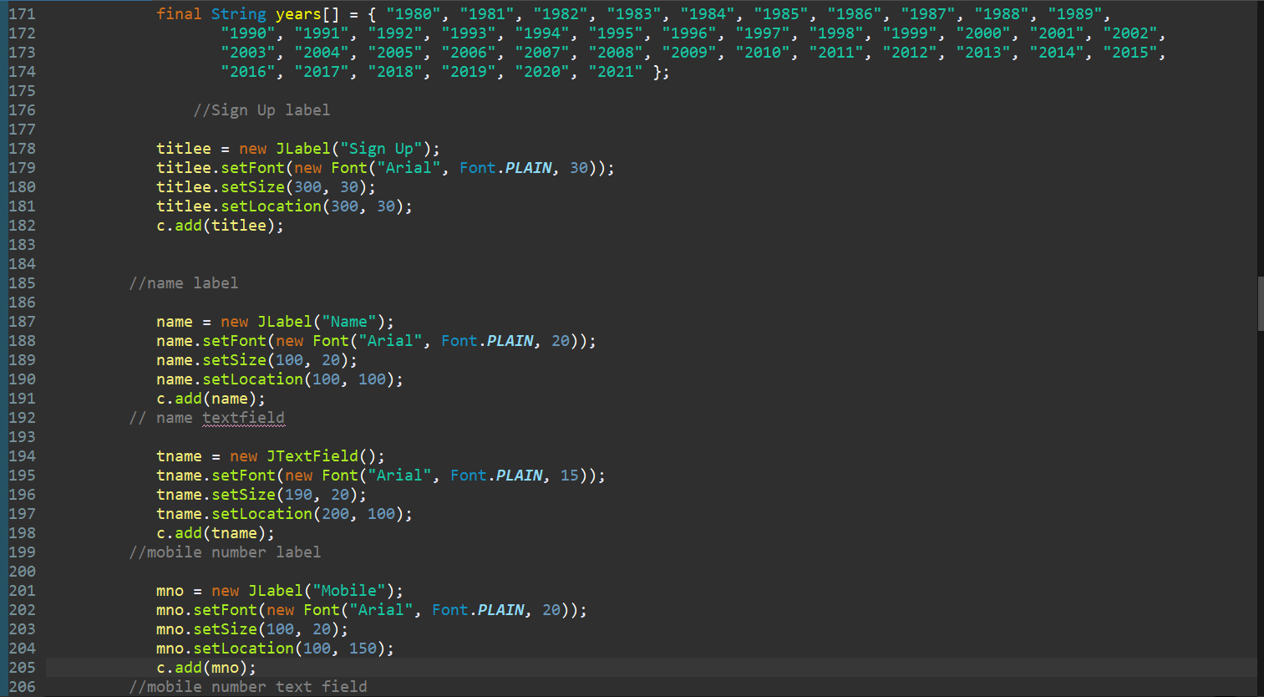

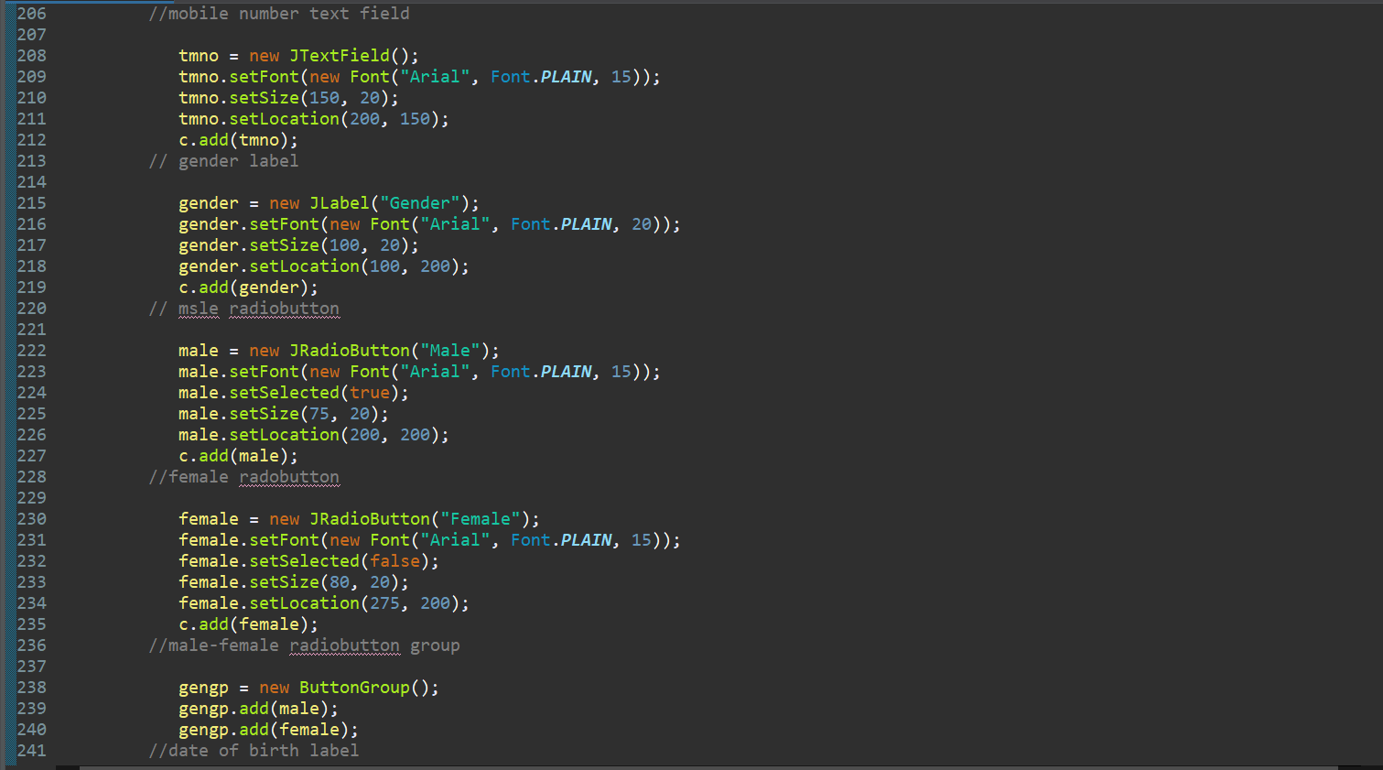

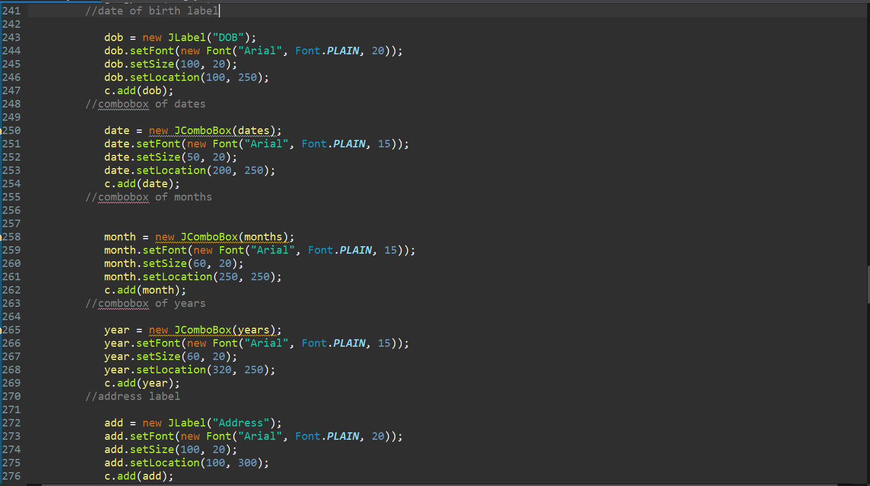

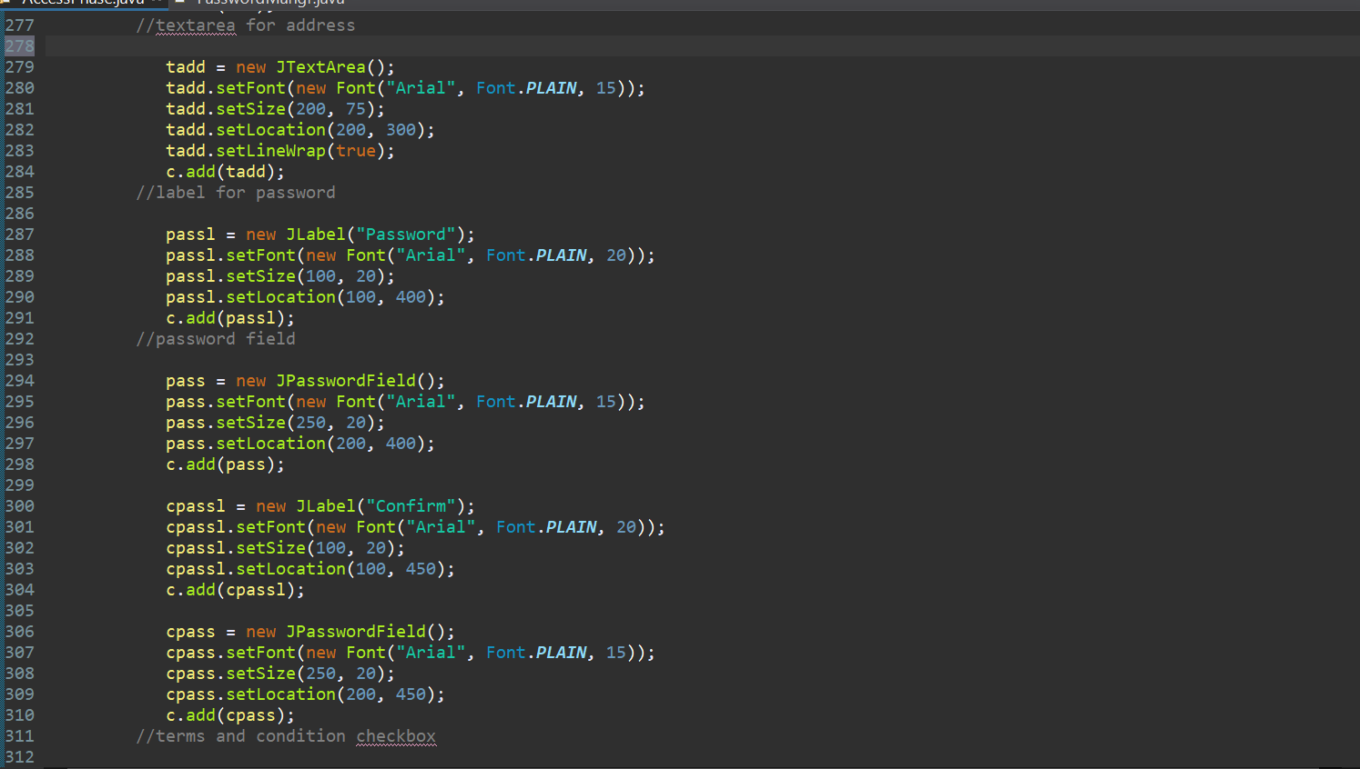

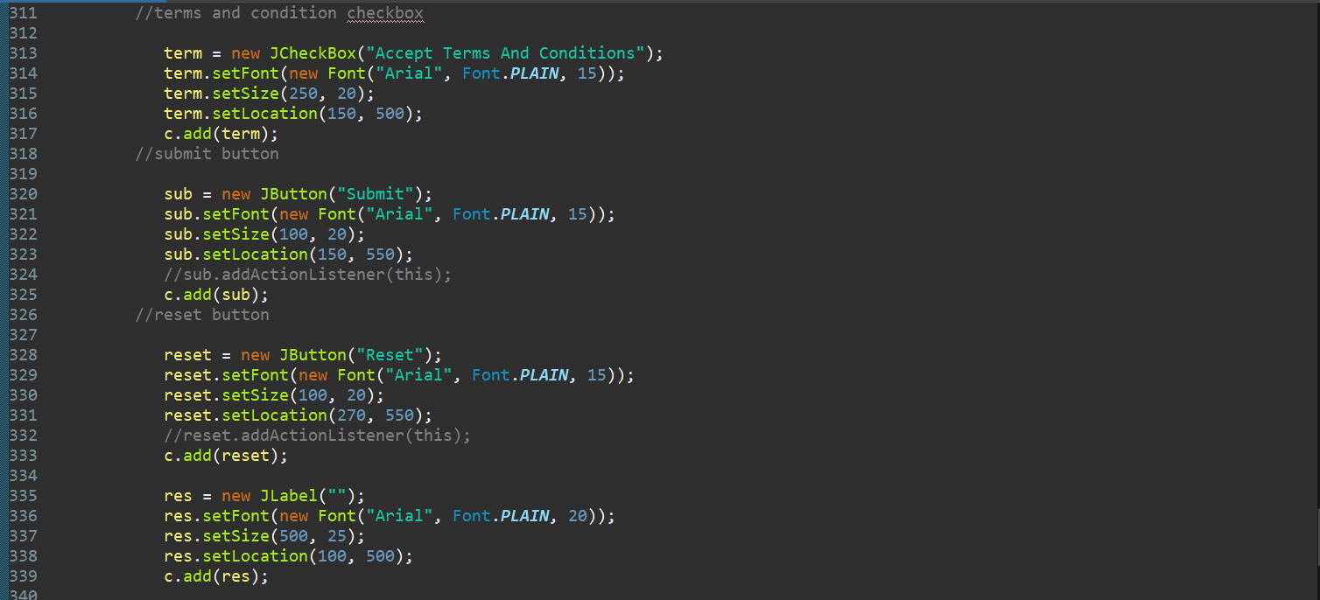

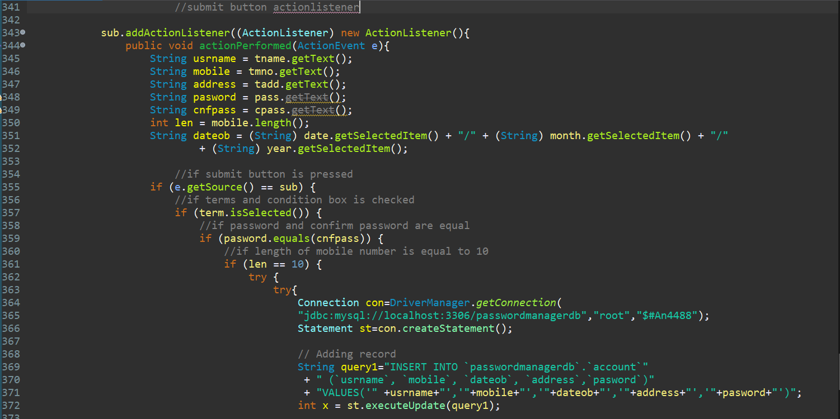



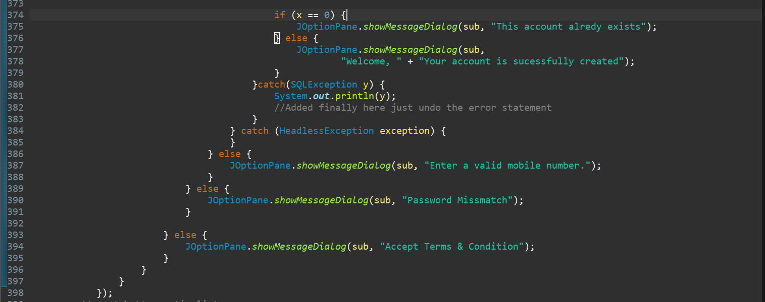

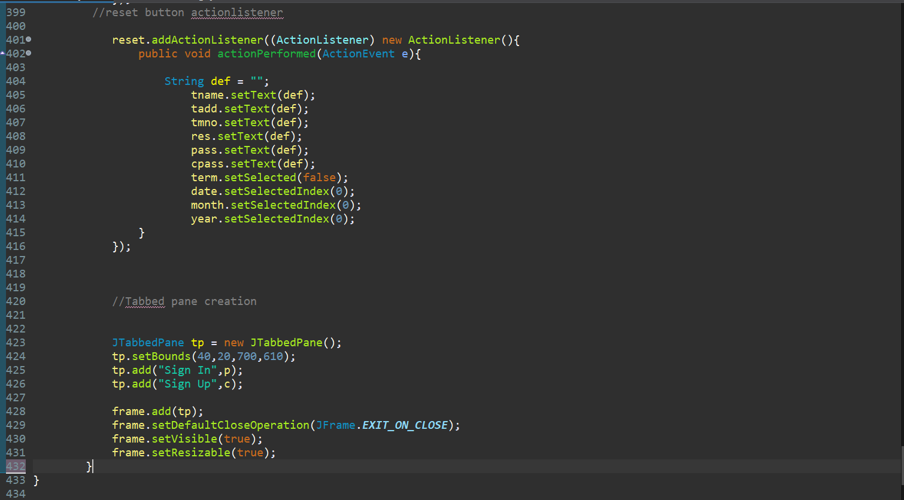

Password Details Into Database (Defined in different class):

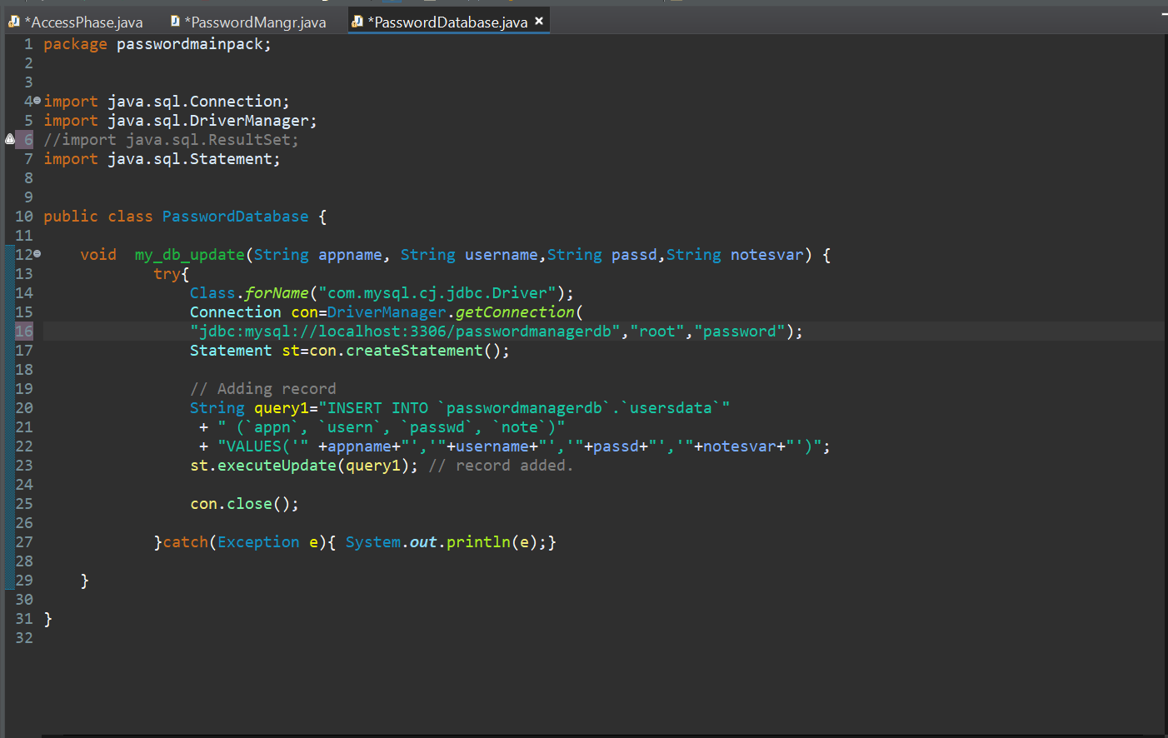



**OUTPUTS:**

Sign Up page: -

Case 1 : Mobile number verification

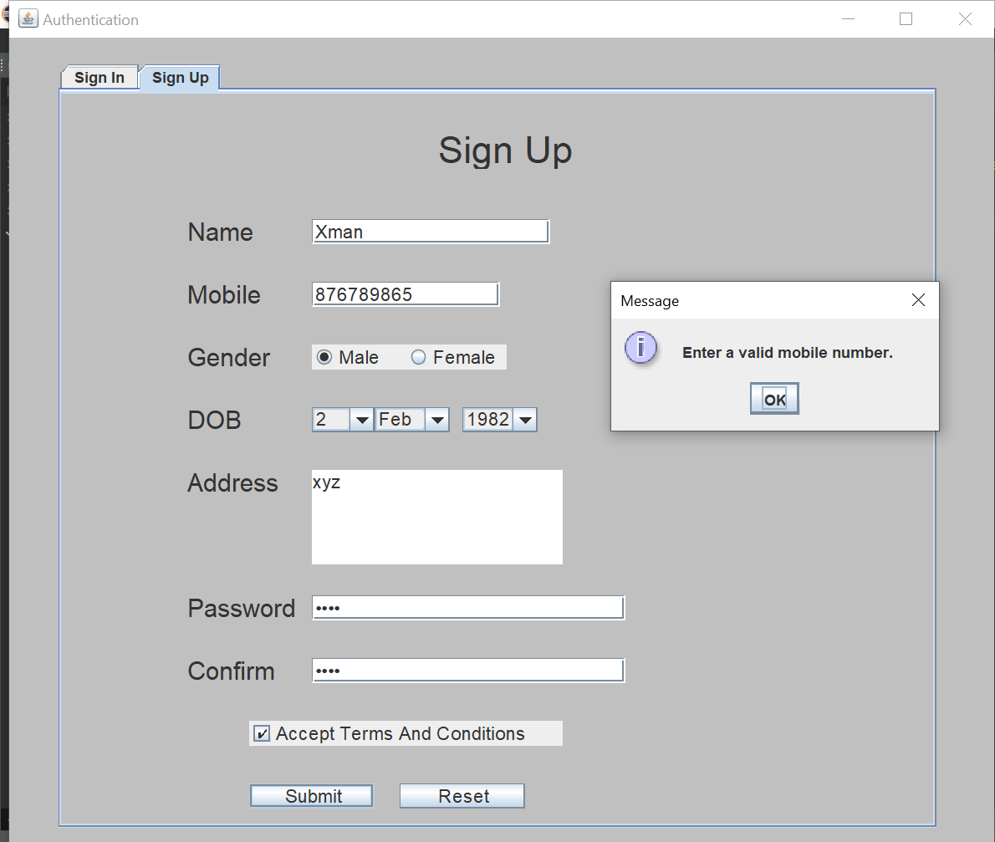

Case 2 : Checking for the same entry in the password and the confirm password section.

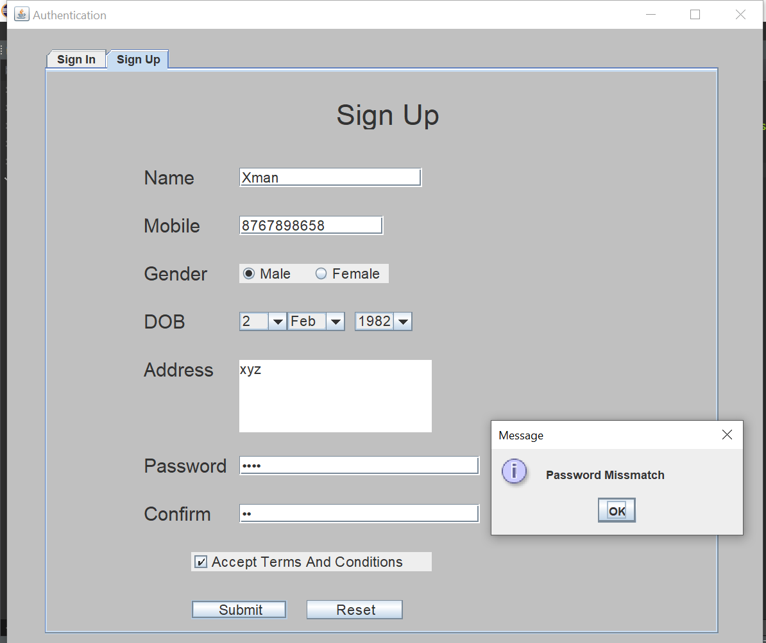

Case 3 : Checking whether the privacy policy is accepted or not

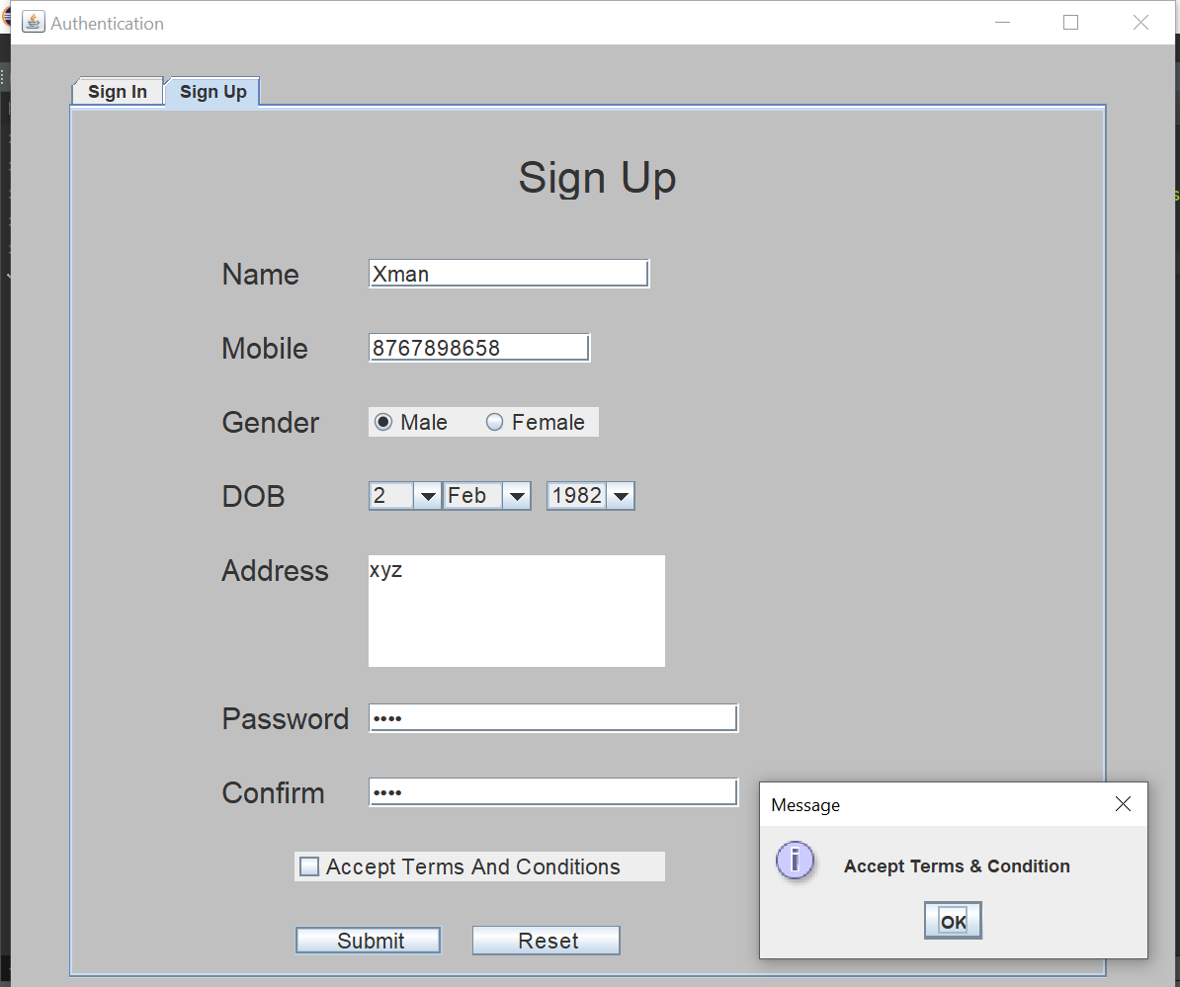

Case 4 : Successful submission

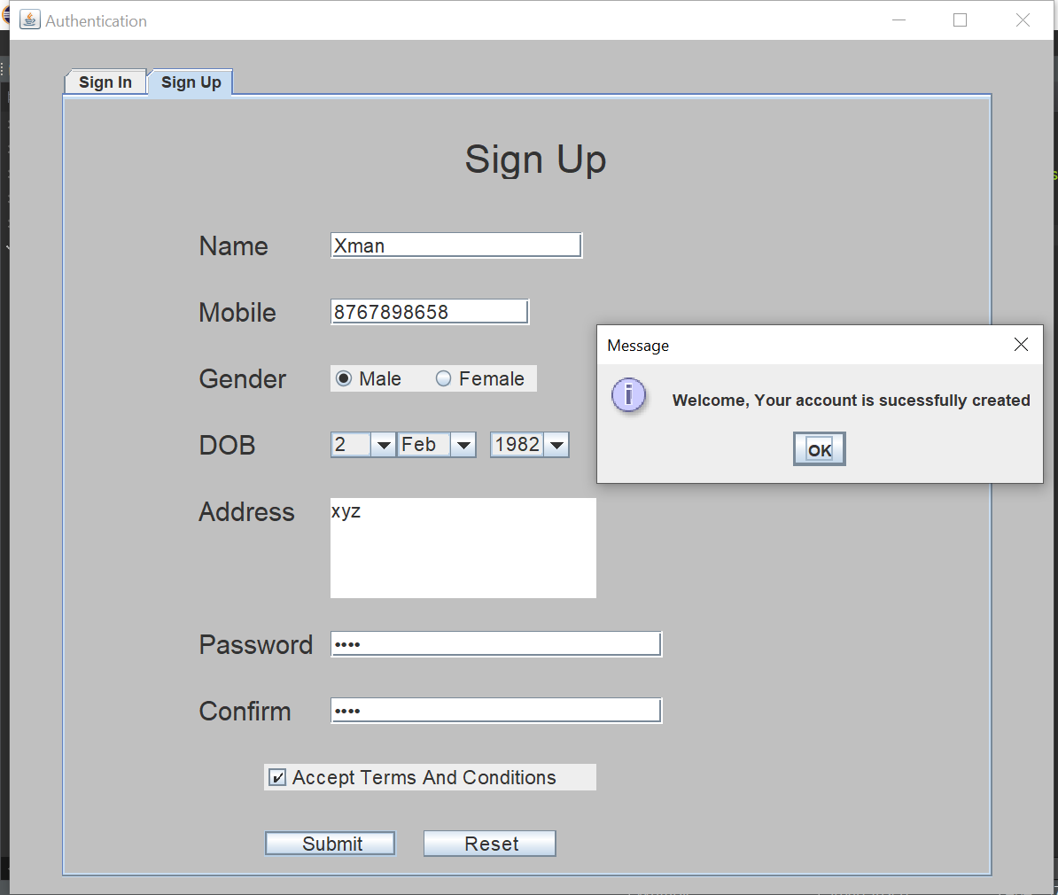

Sign In page: -

Case 1 : Password authentication or validation

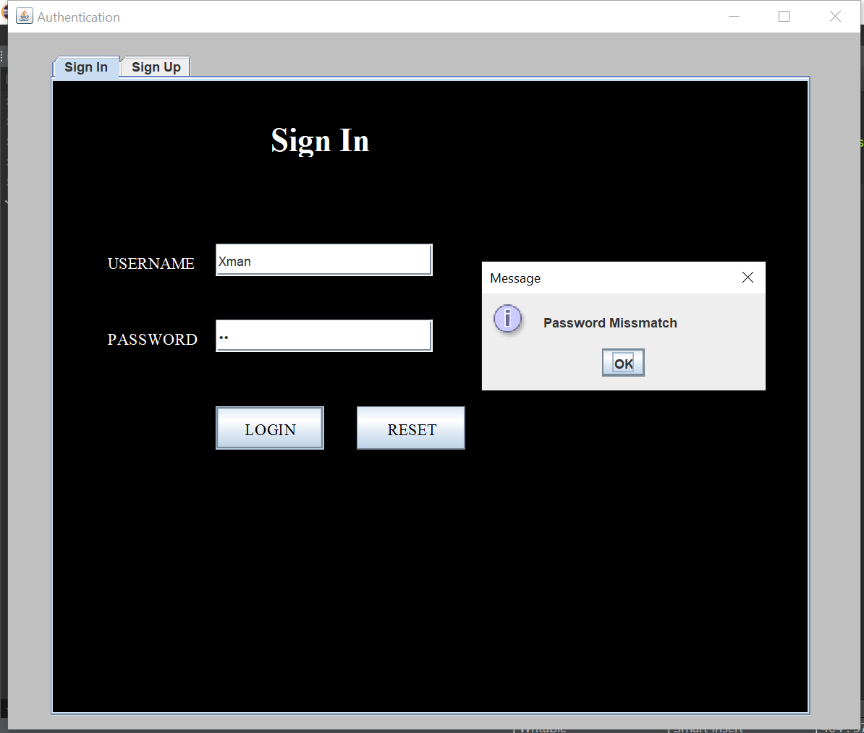

Case 2: Successful sign in

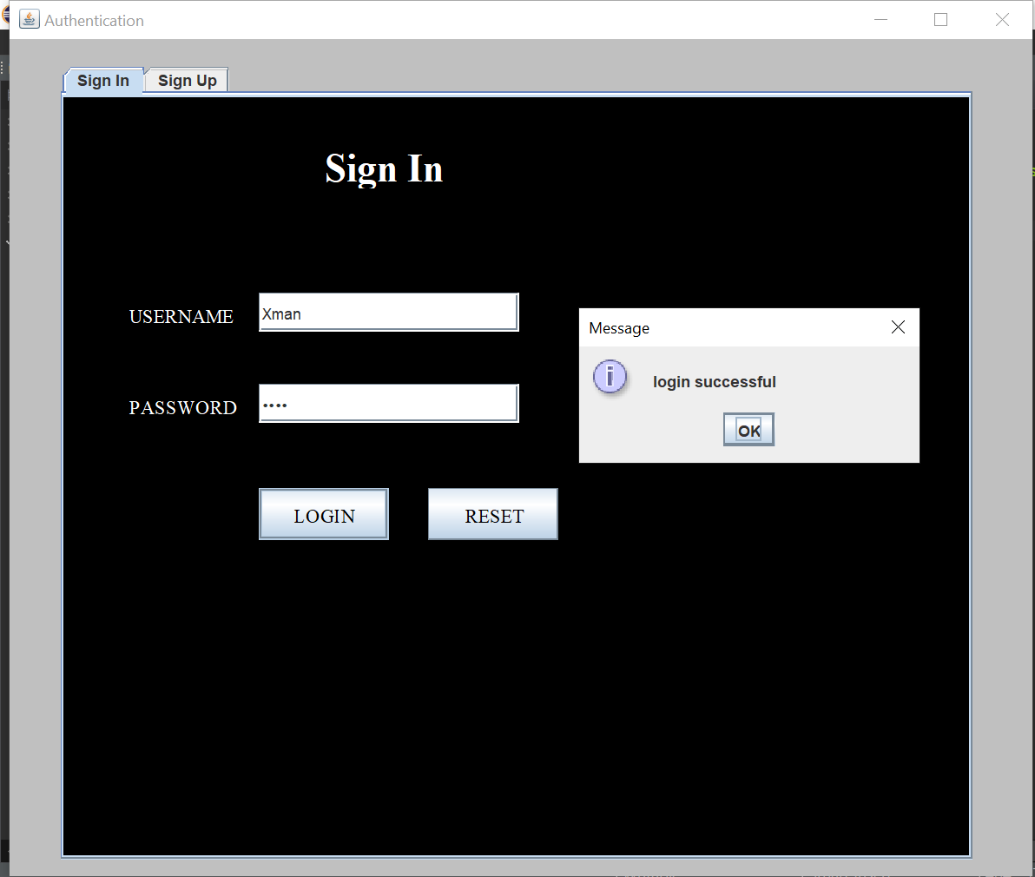

Main Project Secure Pass :

Case 1 : Initial Appearance to the user

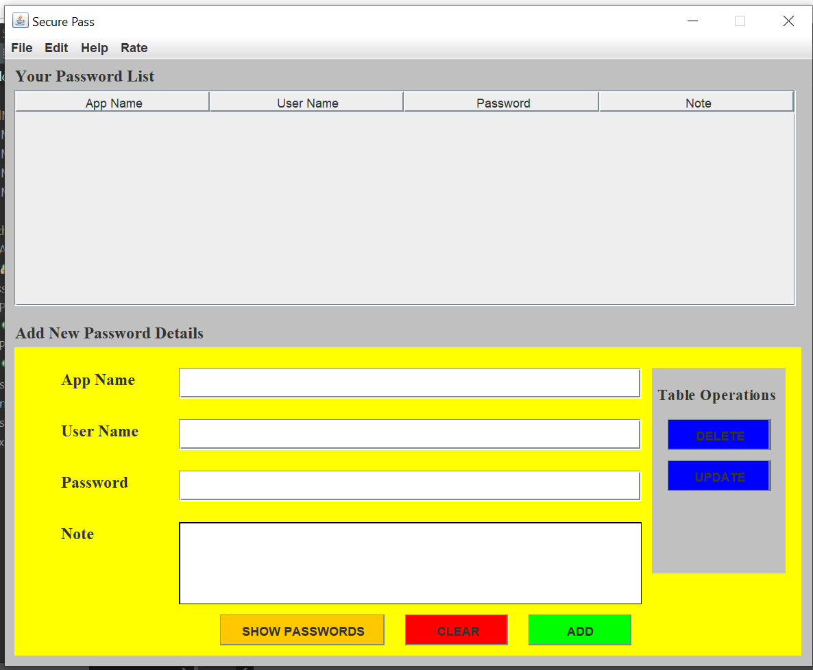

Case 2 : After pressing the SHOW PASSWORD button previously saved passwords loads into table

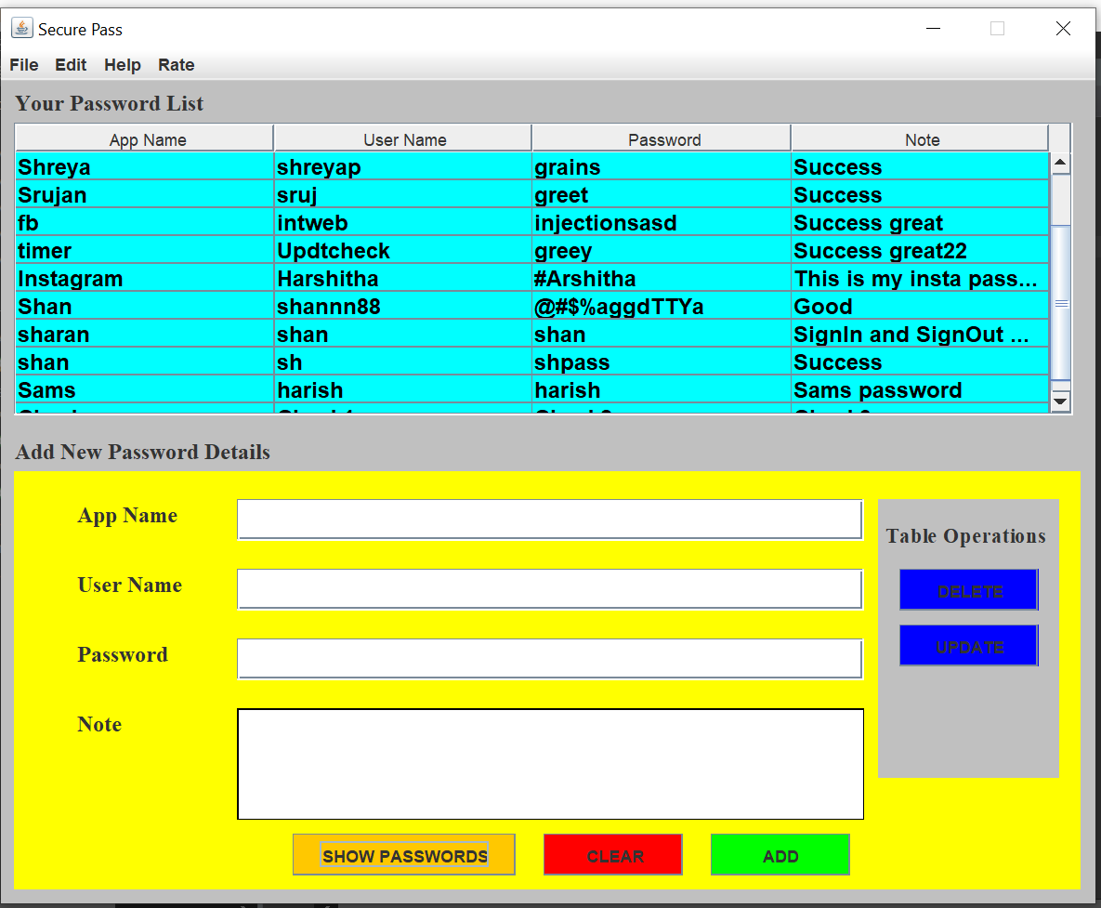

Case 3: Adding Content(Passwords which needs to be stored) to the table pressing ADD button.

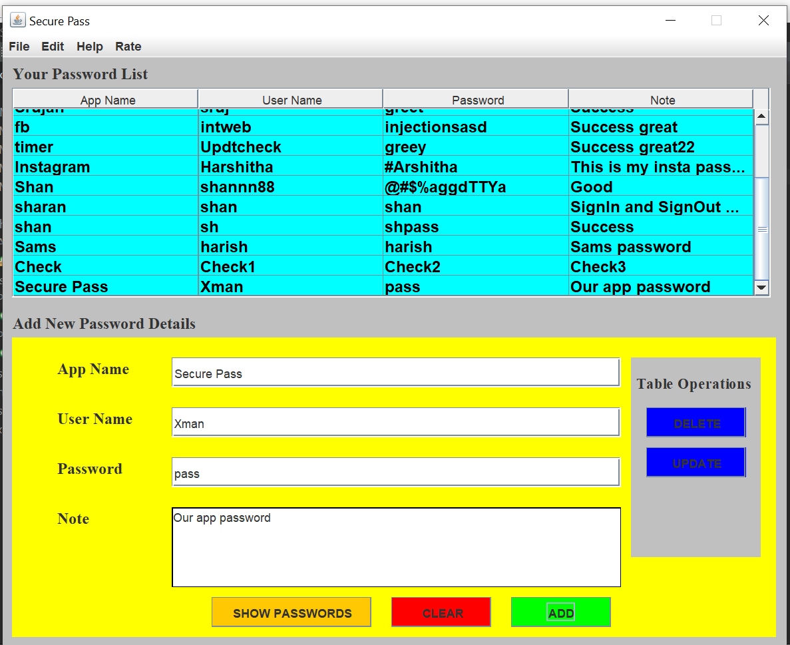

Case 4: Clearing The text boxes using the CLEAR button.

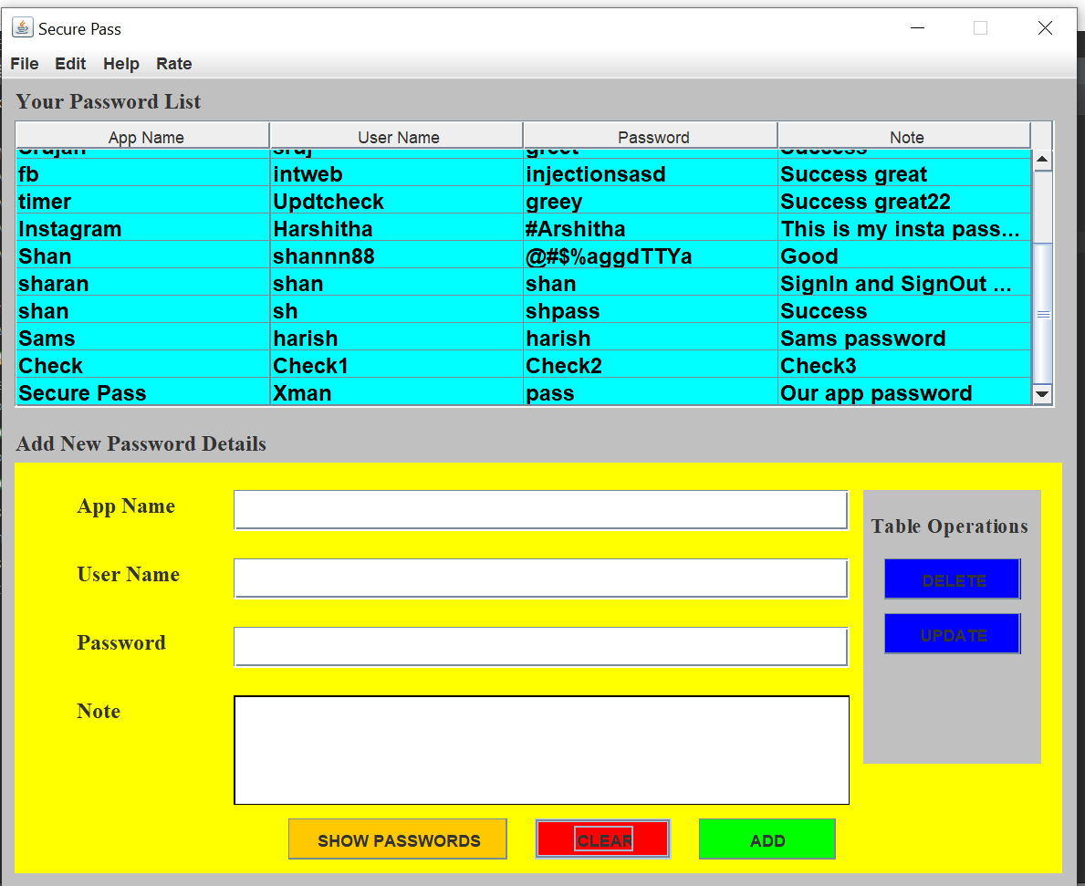

Case 5: Updating the already existing content using the update button.

(view the previous slide to see what was there before updating the content)

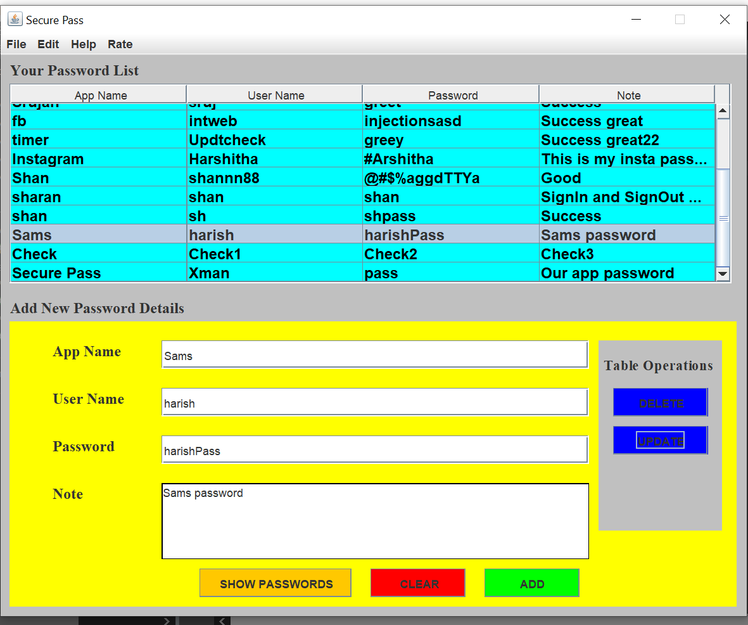

Case 6: The deletion of the content from the table is done using the DELETE button.

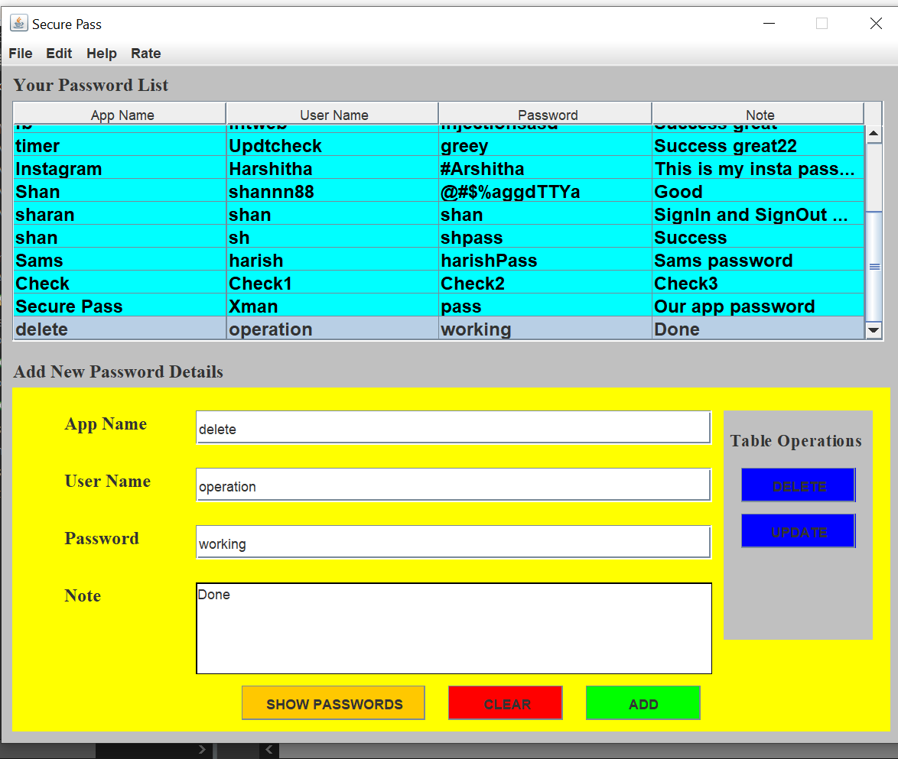

After performing Delete operation the row gets deleted.

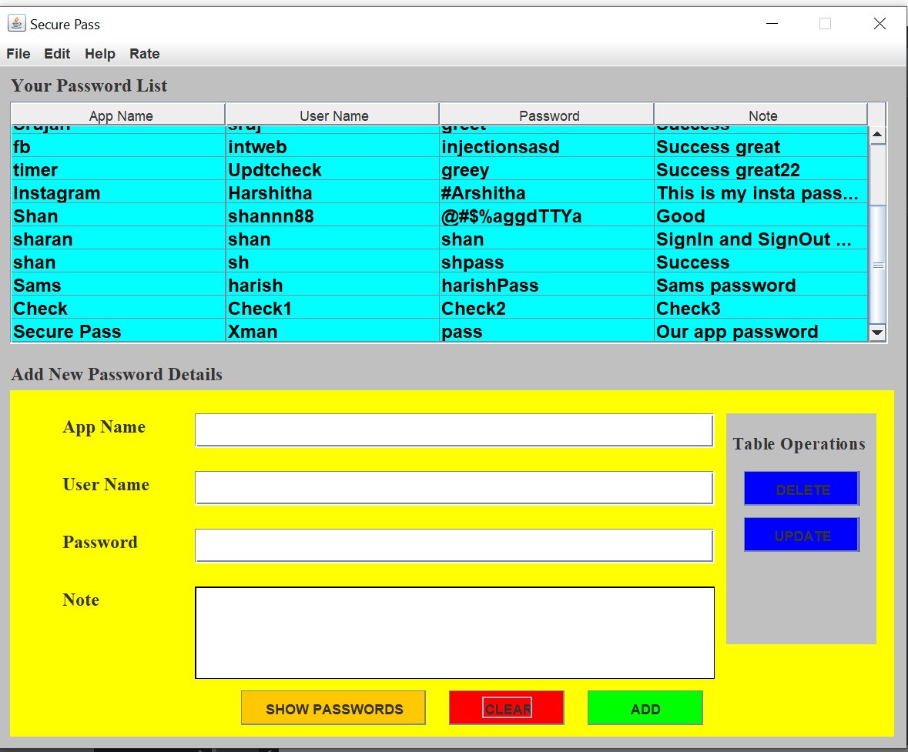

Many other functions like menu bar operations are there to add here but it would create great difficulty. So everything will be shared at the time of project live demo.

**Thank You**

**We appreciate for spending time on this.**

**************************************************************************